2. SIGNAL PROPERTIES AND TRANSFORMATIONS
Experiment 2.1
Periodic and Aperiodic Signals

Aim:
To generate and distinguish between periodic and aperiodic signals using MATLAB. The Aim is to demonstrate the fundamental difference between periodic and aperiodic signals by creating examples of each and analyzing their properties.

Program:
% Periodic and Aperiodic Signals clc;
clear; close all;
% Time axis t = -5:0.01:5;
% Periodic Signal (Sine Wave) x1 = sin(2*pi*t);
% Aperiodic Signal (Exponential Decay) x2 = exp(-abs(t));
% Plotting figure; subplot(2,1,1);
plot(t,x1,'LineWidth',2); grid on;
title('Periodic Signal'); xlabel('Time (s)'); ylabel('Amplitude'); subplot(2,1,2); plot(t,x2,'LineWidth',2); grid on;
title('Aperiodic Signal'); xlabel('Time (s)'); ylabel('Amplitude');

Output Waveform:

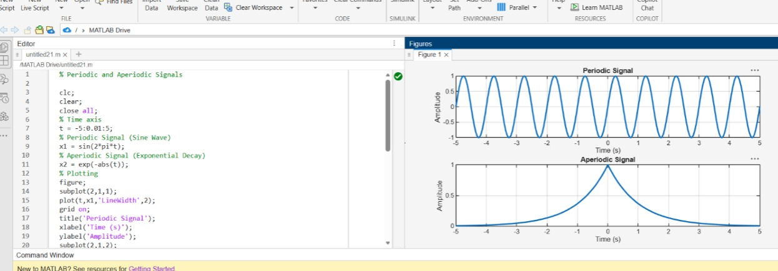

Result:
- Periodic Signal: The sinusoidal signal repeats itself at regular intervals, making it periodic.
- Aperiodic Signal: The exponentially decaying signal does not repeat, showcasing that it is aperiodic.
This test case illustrates the key differences between periodic and aperiodic signals by generating and visually analysing both types using MATLAB.

Experiment 2.2
Verification of Even and Odd Signal Decomposition

Aim
Decompose a signal into even and odd parts and verify reconstruction.

Apparatus Required
PC with MATLAB.

Program (MATLAB)
% Verification of Even and Odd Signal Decomposition clc;
clear; close all;
% Time axis t = -5:0.1:5;
% Original Signal x = t.^3 + t;
% Time-reversed Signal x_rev = (-t).^3 + (-t);
% Even Component xe = (x + x_rev)/2;
% Odd Component xo = (x - x_rev)/2;
% Reconstruction of Original Signal x_reconstructed = xe + xo;
% Plotting figure; subplot(4,1,1);
plot(t,x,'LineWidth',2); grid on;
title('Original Signal x(t)'); xlabel('Time'); ylabel('Amplitude'); subplot(4,1,2);

plot(t,xe,'LineWidth',2); grid on;
title('Even Component x_e(t)'); xlabel('Time'); ylabel('Amplitude'); subplot(4,1,3); plot(t,xo,'LineWidth',2);
grid on;
title('Odd Component x_o(t)'); xlabel('Time'); ylabel('Amplitude'); subplot(4,1,4);
plot(t,x_reconstructed,'LineWidth',2); grid on;
title('Reconstructed Signal x_e(t) + x_o(t)'); xlabel('Time');
ylabel('Amplitude');

Output Generated Graph
Original signal plus even (dashed) and odd (dotted) components.
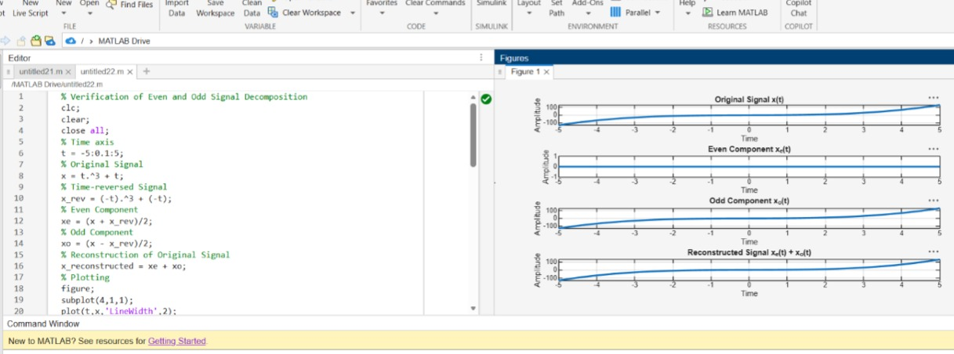

Result
Signal equals sum of even and odd parts.

Experiment 2.3
Amplitude and Time Scaling of Signals

Aim
Demonstrate amplitude and time scaling.

Apparatus Required
PC with MATLAB.

Program (MATLAB)
% Amplitude and Time Scaling of Signals clc;
clear; close all;
% Time axis t = -5:0.01:5;
% Original Signal x = sin(2*pi*t);
% Amplitude Scaling x_amp = 2*x;
% Time Scaling (Compression) x_time = sin(2*pi*2*t);
% Plotting figure; subplot(3,1,1);
plot(t,x,'LineWidth',2); grid on;
title('Original Signal x(t)'); xlabel('Time (s)'); ylabel('Amplitude'); subplot(3,1,2);

plot(t,x_amp,'LineWidth',2); grid on;
title('Amplitude Scaled Signal 2x(t)'); xlabel('Time (s)'); ylabel('Amplitude');
subplot(3,1,3); plot(t,x_time,'LineWidth',2); grid on;
title('Time Scaled Signal x(2t)'); xlabel('Time (s)'); ylabel('Amplitude');

Output Generated Graph
Three plots: original, amplitude-scaled, time-compressed/expanded.

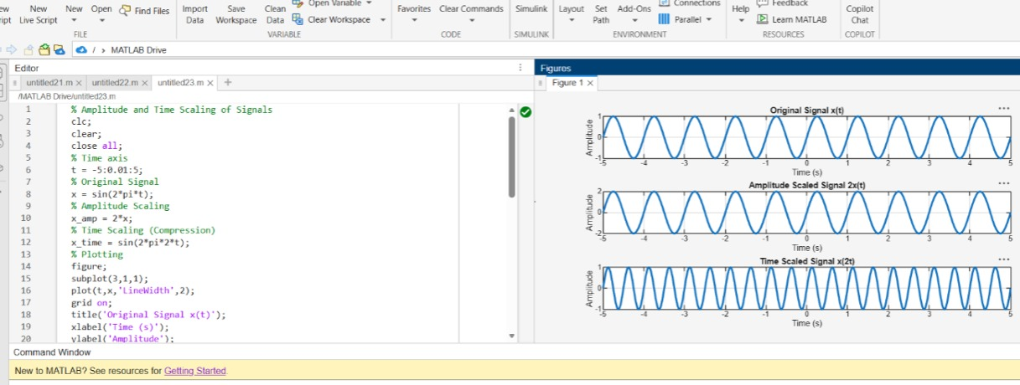

Result
Scaling affects amplitude or time axis accordingly.

Experiment 2.4
Time Shifting and Time Reversal of Signals

Aim
Demonstrate time shift and reversal.

Apparatus Required
PC with MATLAB.

Program (MATLAB)
% Time Shifting and Time Reversal of Signals clc;
clear; close all;
% Time axis t = -5:0.01:5;
% Original Signal x = sin(2*pi*t);
% Time Shift (Delay by 2 seconds) x_shift = sin(2*pi*(t-2));
% Time Reversal x_reverse = sin(2*pi*(-t));
% Plotting figure; subplot(3,1,1);
plot(t,x,'LineWidth',2); grid on;
title('Original Signal x(t)'); xlabel('Time (s)'); ylabel('Amplitude'); subplot(3,1,2); plot(t,x_shift,'LineWidth',2); grid on;
title('Time Shifted Signal x(t-2)'); xlabel('Time (s)');

ylabel('Amplitude'); subplot(3,1,3); plot(t,x_reverse,'LineWidth',2); grid on;
title('Time Reversed Signal x(-t)'); xlabel('Time (s)'); ylabel('Amplitude');

Output Generated Graph
Original, shifted, and reversed signals.

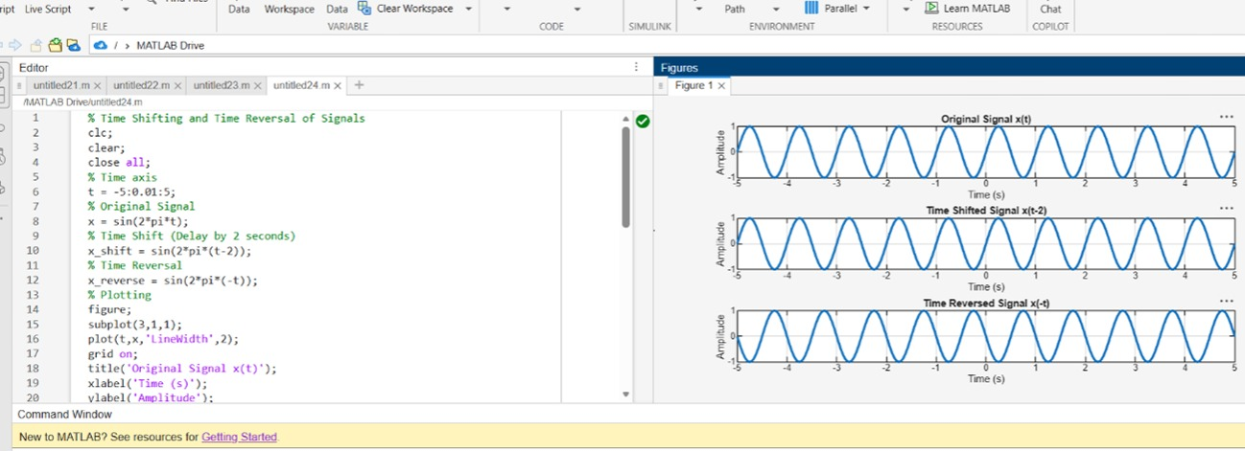

Result
The sinusoidal signal was successfully subjected to time shifting and time reversal using MATLAB. The time-shifted signal was delayed by 2 seconds, while the time-reversed signal was obtained by reflecting the original signal about the vertical axis, demonstrating fundamental signal transformation operations.

